Fightn’Five

Justin Gewecke

CST-452 Release Phase

Grand Canyon University

Instructor: Professor Bradley Mauger

Revision: 1.4

Date: 11/06/2022

**ABSTRACT**

This project’s goal is to make a fun video game that can be made within the timespan of a month. The video game will only be available on Windows machines; the application window will function like other applications, such as Spotify, Chrome, and Paint in how you can close, minimize, and expand the application. The game will be accessible on most (if not all) windows configurations.

This project will be made using the Unity Game Engine. Essentially, this engine will create the visual GUI for my game that users can interact with. However, this GUI is a blank canvas that requires coding to add any functionality to it. To accomplish this, I will utilize C# scripts that can interact with that visual GUI. All the game data and logic will be stored in these C# files. Otherwise, no other external tools or frameworks will be used. As an alternative solution Unity, MonoGame is also a possible solution. Instead of being an engine, MonoGame is a C# framework that make it easy to make a Windows application—but it requires a lot more user intervention to get something out of it.

The game will consist of a main menu, which includes a settings menu, and a start/exit button. When starting the game, the user can fight 50 battles in an increasing difficulty curve. Once the user beats the last battle, they win. Each battle is turn-based, so the player takes a turn once the enemy finishes. As the player plays the game, they may also save/load their data to continue playing later.

|  |
| --- |
| History and Signoff Sheet |

**Change Record**

|  |  |  |
| --- | --- | --- |
| **Date** | **Author** | **Revision Notes** |
| 9/25/2022 | Justin Gewecke | Initial draft for review/discussion |
| 10/2/2022 | Justin Gewecke | Initial project requirements outlined |
| 10/16/2022 | Justin Gewecke | Matches requirements to user stories |
| 10/23/2022 | Justin Gewecke | Updated information on testing and current features. |
| 10/30/2022 | Justin Gewecke | Added more unit tests to the application. Battle buttons now highlight a different color when pressed. This should make it easier to see what ability is selected. I also did some QA on the application. |
| 11/6/2022 | Justin Gewecke | Finished commenting all source code. Finished portfolio website for game. Added a non-functionality requirement. Added, portfolio link. Updated wish list for future requirements. |

|  |
| --- |
| **Overall Instructor Feedback/Comments** |

|  |
| --- |
| **Overall Instructor Feedback/Comments** |

**Integrated Instructor Feedback into Project Documentation**

Yes  No

**TABLE OF CONTENTS**

Functional Requirements 4

Non-Functional Requirements 5

Technical Requirements 6

Logical System Design 7

User Interface Design 8

Reports Design 9

Functional Requirements

**Use Cases**

|  |  |  |
| --- | --- | --- |
| **Use Case or User Story** | **Justification** | **Implemented?** |
| **As a user, I want to be able to adjust the volume of the game.** | **Make the game more comfortable for the user's ears** | **Yes, game has sound.** |
| **As a user, I want to be able to mute the game.** | **This will allow the user to listen to music or podcasts during the gaming session.** | **Yes, the game can be muted.** |
| **As a user, I want to easily see the progress of my game.** | **Make the situation of the game obvious. The user can know how close they are to finishing the game.** | **Yes, implemented as game board.** |
| **As a user, I want to be able to upgrade my units.** | **This will provide the user with a sense of progress.** | **Yes, the player can upgrade units.** |
| **As a user, I want to be able to save/load my game’s progress.** | **This will allow the user to continue their session at different times even when closing the game.** | **Yes, game can be saved and loaded.** |
| **As a user, I want to see the enemy’s info during battle.** | **This will inform the user of the situation.** | **Yes, you can see enemy health status.** |
| **As a user, I want to see my info during battle.** | **This will inform the user of the situation.** | **Yes, you can see player health status.** |
| **As a user, I want to see my actions.** | **This will show what the user can do during a move.** | **Yes, the player has some actions shown to them.** |
| **As a user, I want my enemy to do actions by themselves.** | **This will allow the user to play the game without a second person.** | **Yes, AI does moves by themselves.** |
| **As a user, I want to experience defeat when my team is lacking.** | **This will show the user that they need to progress further.** | **Yes, the player can lose a battle.** |
| **As a user, I want to experience victory.** | **This will allow the user to feel good about progressing.** | **Yes, the player can win the battle and win the game.** |

Non-Functional Requirements

**Use Cases**

|  |  |  |
| --- | --- | --- |
| **Use Case or User Story** | **Justification** | **Implemented?** |
| **As a user, I want my experience to not feel slow/sluggish when interacting with the application.** | **This will ensure a smooth game experience.** | **Yes, the game feels smooth to play.** |
| **As a user, I want to play this game on my PC.** | **This limits the platform in which this game can be played.** | **Yes, this game can be played on PC.** |
| **As a user, I should quickly be able to load/save my game progress.** | **This will make loading/saving games a fast and easy experience.** | **Yes, the player can load and save their game status quickly.** |
| **As a user, I want the game to startup as quickly as possible.** | **This will provide the user more time to play the game.** | **Yes, the game loads quickly.** |
| **As a user, I want an easy way to install the game.** | **This will make it easy for the user to install and play the game.** | **Yes, the game can be downloaded then played.** |
| **As a user, I want to play this on an older operating system.** | **This will allow more players to play the game.** | **Yes, the game has been tested with Windows Vista+ machines using Windows 10’s compatibility mode.** |
| **As a user, I want a website to view information about this game.** | **This will allow users to find, learn, and download the game.** | **Yes, this was implemented using GitHub Pages.** |

Technical Requirements

**Use Cases**

|  |  |  |
| --- | --- | --- |
| **Technology or Tool** | **Justification** | **Implemented?** |
| **Unity Game Engine** | **This will allow me to work a lot faster since I won’t have to focus on the game rendering and GUI. Instead, I can focus on the game data and programming logic.** | **Yes, this allowed for quick game development.** |
| **Visual Studio** | **This pairs seamlessly with Unity. Allowing me to focus on coding the application.** | **Yes, this is used in conjunction with Unity to handle the coding. Unity is not an IDE.** |

|  |  |  |  |  |  |  |  |  |
| --- | --- | --- | --- | --- | --- | --- | --- | --- |
|  | **Project Name:** | **Test Designed by:** | **Justin Gewecke** |  |  |  |  |  |
| **Module Name:** | **Test Designed date:** | 10/30/2022 |  |  |  |  |  |
|  | **Release Version:** | **Test Executed by:** | **Justin Gewecke** |  |  |  |  |  |
|  |  | **Test Execution date:** | 10/30/2022 |  |  |  |  |  |
|  |  |  |  |  |  |  |  |  |
|  |  |  |  |  |  |  |  |  |
| **Test Case#** | **Test Title** | **Test Steps** | **Test Data** | **Expected Result** |  | **Actual Result** | **Pass/Fail Status** | **Notes** |
| 0 | Load Game | Press Load Game button | 10/16/2022 | Game loads previous save | Game loads save |  | Pass | Creating a unit test for this caused errors. |
| 1 | Save Game | Press Save Game button | 10/16/2022 | Game saves game state | Game saved game state |  | Pass | Creating a unit test for this caused errors. |
| 2 | Can start game | Open game .exe | 10/16/2022 | Game starts | Game started |  | Pass |  |
| 3 | Load Game board | Start game from main menu | 10/16/2022 | Game loads game board | Game loaded game board |  | Pass |  |
| 4 | Load Battle | Click on a fight | 10/16/2022 | Fight loads | Fight loads |  | Pass |  |
| 5 | Game victory | Beat 15 battle stages | 10/16/2022 | Game shows victory scene | Game showed victory scene |  | Pass |  |
| 6 | Mute game | Click ‘mute’ button | 10/23/2022 | Game sound mutes | Game sounds mutes |  | Pass | The result “could” be tested, but this must be tested manually to confirm no audio. |
| 7 | Adjust volume | Slide volume slider | 10/23/2022 | Game sound adjusts | Game sound adjusted |  | Pass | The result “could” be tested, but this must be tested manually to confirm no audio. |
| 8 | Upgrade Unit | Click ‘Upgrade’ button for each unit | 10/23/2022 | Unit gets more damage | Unit dealt more damage |  | Pass |  |
| 9 | Play Battle | Load a battle and play until victory/defeat | 10/23/2022 | Game finishes without any hitches | Battle progressed and finished smoothly. |  | Pass |  |
| 10 | Delete Game | Delete game folder | 10/23/2022 | Game deletes without stopping user | Game went to recycle bin |  | Pass |  |
| 11 | Play on Old OS | Run game in compatibility mode with Windows Vista+ | 10/30/2022 | Game runs and behaves correctly. | The game ran and behaved correctly. |  | Pass | Testing on the actual OS would provide better results. |

|  |  |  |  |  |  |  |  |  |
| --- | --- | --- | --- | --- | --- | --- | --- | --- |
| **REQUIREMENTS TRACEABILITY MATRIX** | | | |  |  |  |  |  |
| Project Name: |  | Fightn’Five |  |  |  |  |  |  |
| Project Description: | | A small RPG video game. | |  |  |  |  |  |
| ***ID*** | ***Assoc ID*** | ***Functional Requirement / Use Case*** | ***Architectural/Design Document*** | ***Software Module(s)*** | **Test Case Number** | **Additional Comments** | | |
| 001 | 1.1.1 | **As a user, I want to be able to adjust the volume of the game.** | See figure below | Settings | 7 |  | | |
| 002 | 2.2.2 | **As a user, I want to be able to mute the game.** | See figure below | Settings | 6 |  | | |
| 003 | 3.3.3 | **As a user, I want to easily see the progress of my game.** | See figure below | Game Board | 3 | Completed stages are green, current floor to be challenged is red. | | |
| 004 | 4.4.4 | **As a user, I want to be able to upgrade my units.** | See figure below | Character Upgrade | 8 | Relevant tests:  TestUpgradeBonusAttack()  TestCharacterDamageCalculation() | | |
| 005 | 5.5.5 | **As a user, I want to be able to save/load my game’s progress.** | N/A | Save/Load System | 0 and 1 | Saves and loads floor progress. | | |
| 006 | 6.6.6 | **As a user, I want to see the enemy’s info during battle.** | See figure below | Battle System | 9 |  | | |
| 007 | 7.7.7 | **As a user, I want to see my info during battle.** | See figure below | Battle System | 9 |  | | |
| 008 | 8.8.8 | **As a user, I want to see my actions.** | See figure below | Battle System | 9 |  | | |
| 009 | 9.9.9 | **As a user, I want my enemy to do actions by themselves.** | See figure below | Battle System | 9 |  | | |
| 010 | 10.10.10 | **As a user, I want to experience defeat when my team is lacking.** | See figure below | Battle System | 9 |  | | |
| 011 | 11.11.11 | **As a user, I want to experience victory.** | See figure below | Battle System | 9 |  | | |
| 012 | 12.12.12 | **As a user, I want my experience to not feel slow/sluggish when interacting with the application.** |  | All Modules | 2 |  | | |
| 013 | 13.13.13 | **As a user, I want to play this game on my PC.** |  | All Modules | 3 |  | | |
| 014 | 14.14.14 | **As a user, I should quickly be able to load/save my game progress.** |  | Save/Load System | 0 and 1 |  | | |
| 015 | 15.15.15 | **As a user, I want the game to startup as quickly as possible.** |  | All Systems | 2 |  | | |
| 016 | 16.16.16 | **As a user, I want an easy way to install the game.** | See figure below | All Systems | 10 |  | | |
| 017 | 17.17.17 | **As a user, I want to play this game on an older OS** | N/A | All Systems | 11 |  | | |



**Figure 1: Game design and interface**

**Figure 2: User game download experience.**

**Figure 3: Visual representation of how the system works.**

**Figure 4: Another representation of the system.**

**Figure 5: Process flow for testing.**

Appendix A – External Resources

|  |  |  |
| --- | --- | --- |
| **GIT URL:** | [*https://github.com/Icefireburn1/FightnFive*](https://github.com/Icefireburn1/FightnFive) |  |
| **Application Showcase:** | <https://youtu.be/oU-FXOhyrIg> | With this testing phase, a new video was not made. Video was posted 10/23/2022. |
| **Portfolio Website:** | <https://icefireburn1.github.io/FightnFive/> | Made using GitHub Pages |

**Note: A built executable of the video game application can be downloaded from “Releases” inside of GitHub if needed.**

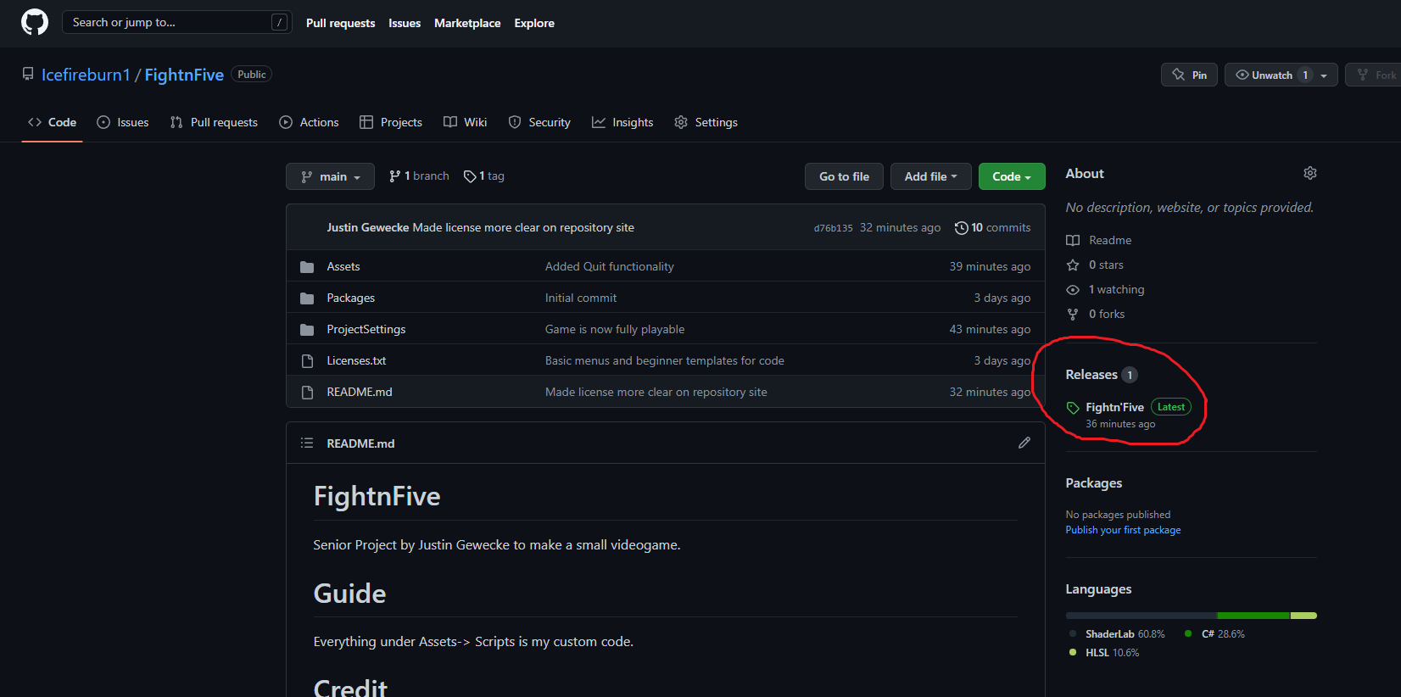

Appendix B – Future Improvements

From testing the application as a consumer, I will highlight some of the improvements that I think could be made for Fightn’Five that would make it a better product. These are features/improvements that were *not* a part of the original planning process. If I was a consumer, I would love to see these new additions as a future deployment, for example.

1. Victory screen could be more exciting/rewarding—it is dull in terms of visuals and interactions.
2. It would be nice to see what player character is moving at any given time during a battle. Right now, you sort of must assume what character is moving.
3. More abilities, player characters, enemies, and floors would make the game more interesting.
4. More settings for the application. Being able to choose windowed mode, resolution options, and individual music/sound options would be nice.
5. Add more polish to the “small” things. Could be more small sounds that chime during certain interactions. Or maybe different music depending on the type of battle. Boss music would be a good example.
6. Letting the player name their characters could be fun—it could make them more invested in their characters.

If this game would be sold in the future, it could also use a more “proper” website. Likewise, it would need to be available on common game stores such as Steam or Itch.io.